Cocktail Quiz – Margot Houdoux

- Imaginative Journey: If you could have a cocktail in any imaginary or fantasy setting, where would it be? Select 1.
- On a luxurious interstellar cruise traveling through space

- Taste Preference: What flavor profile do you prefer in your drinks? Max 3.
- Bitter
- Spicy

- Sweetness Level: How sweet do you like your cocktails?
- Just a hint of sweetness

- Mood Setter: What activity or environment makes you feel most relaxed and happy?
- Being outdoors, like a walk in nature or a day at the beach

- Drink Type Preference: Do you prefer short or long drinks? Choose one example that appeals to you the most.
- Old Fashioned, Margarita (Short Drink)

- Carbonation Preference: Do you enjoy carbonation in your drinks?
- Indifferent

- Which country or city do you feel most attached to?
City, I would say Rio de Janeiro in Brazil as I fall deeply in love with this city when going a few years ago.
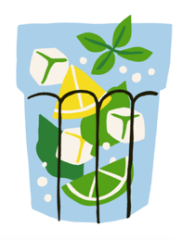
- Allergies and Dietary Restrictions: Do you have any allergies or dietary restrictions we should be aware of?
- No known allergies or restrictions

- Favorite Cocktail (if any): What is your favorite cocktail? (Optional)
Negroni, Caïpirinha, Expresso Martini

- Personal Insight: Is there anything else about yourself that you think we should know to make your cocktail experience more personal? (This can be a flavor you love, one of your favorite memories, something about you, a part of the world you feel connected to, etc.)

My favorite place to enjoy a cocktail is during holidays, while watching a nice sunset over the ocean… warm days are my favourite.
My best cocktail memory is in Brazil, when we used to drink Caipirinhas and dance in the streets of Rio all night long.

